Shreyas Srinivasa

BlazerID: SSRINIVA

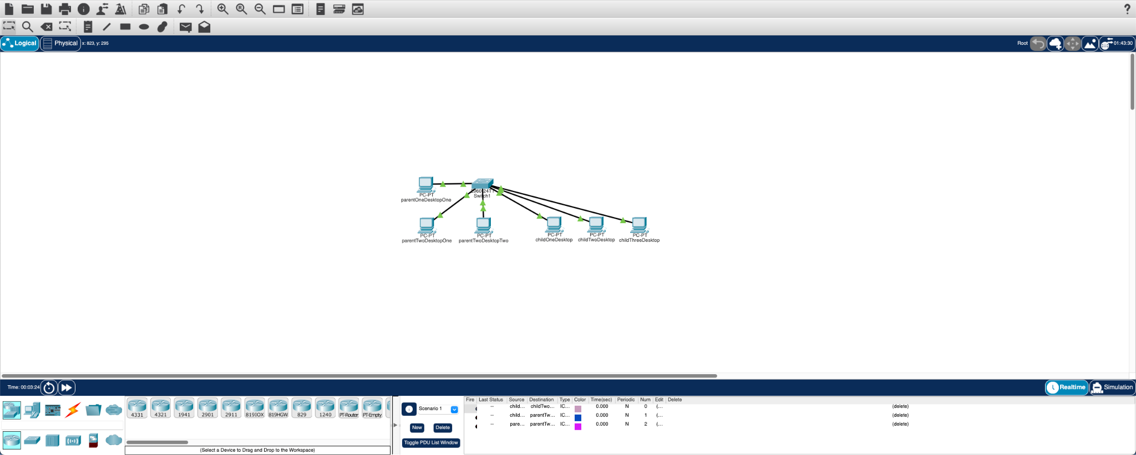

The above image shows the logical implementation of the setup mentioned in the lab documentation.

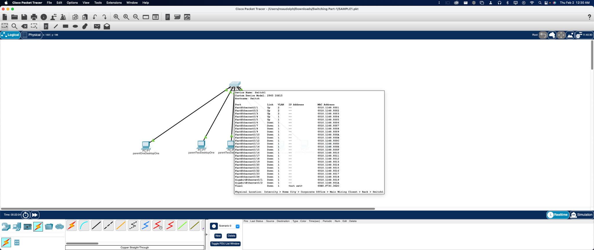With a separate VLAN (2) setup for just the parent’s computers, sendings pings between the parents computers is possible but sendings pings from the children’s to the parents PC or the other way around is impossible due to them being in a different collision domain.

It shows in Scenario 1, shown on the bottom right of the above screenshot that the attempt to send simple PDU between the child’s PC and the parents PC were unsuccessful while the one between the parent’s PC were successful.

2. ARP requests are done to understand which MAC addresses match with a IPv4 address. The computer, when first establishing a connection, uses the ARP to link the host address to the IP address.

3. The ethernet address is used. Which is (ffff.ffff.ffff) It means its sending it all the devices in the network.